**DSP Assignment 1**

**5Th Semester, Fall 2021 (CLO-1)**

Q.1 Consider the analog signal,

$x_{a}\left(t\right)= 3sin⁡(40πt)$

1. Sketch the signal $x_{a}\left(t\right)$ in the interval $0≤t≤75$ ms
2. If the signal $x_{a}\left(t\right)$ is sampled with sampling frequency $F_{s}=120$ hertz, find the frequency of the resultant discrete time signal $x\left(n\right)= x_{a}\left(nT_{s}\right)$, $T_{s}= \frac{1}{F_{s}}$. Is the signal $x\left(n\right)$ periodic?
3. Sketch the samples of $x\left(n\right)$ on the diagram with of $x_{a}\left(t\right)$ developed in part(a). What is the period of $x\left(n\right)$ in number of samples N and time in milli-seconds.

Q.2

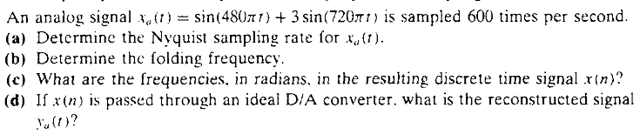

Q.3

A discrete-time signal x[n] = 7.5sine(π/5n + π/6) is quantized with a resolution,

(a) Δ=0.10 (b) Δ=0.05 (c) Δ=0.01

What is the number of number of bits ‘b’ required in the A/D conversion in each of these cases?

This assignment is due on Friday 03rd December 2021, and its associated quiz will also be in the class on Friday 03rd December 2021.